- Which of the following is NOT a property of the yeast strain used for the functional assay?
- It lacks a functional MSH2 gene
- It requires tryptophan to grow
- It requires histidine to grow
- It contains the pSH44 plasmid carrying a mutant URA3 gene
- None of the above

- The potent drug, 5-FOA is used for this assay because
- the URA3 gene combines with it to produce a color change
- it can be converted into a toxic form (5-FU) by an enzyme coded for by the URA3 gene
- it is able to make transformed yeast cells grow
- it does all of the above

- Which of the following statements are true about the pRS413 plasmid?
  - May contain WT or Mutant allele of MSH2 gene
  - It contains His3 gene that rescues the yeast strain from His dependence
  - It contains antibiotic resistance gene that allows for selection of plasmid-containing bacteria during cloning
  - Only A and B are true
  - All of the above are true

- The freezing step in the protein extraction protocol helps to
  - Put the yeast to sleep so that the detergent can work.
  - Break open the yeast’s cell membrane
  - Cool down the temperature of the yeast cells considerably to avoid death before protein extraction.
  - All of the above.
  - None of the above

5. The biological name for the yeast utilized in the second phase of your project is
- Candida Albicans
- Saccharomyces cerevisiae
- Zygosaccharomyces
- Escherisia coli
- Cryptococcus neoformans

- Where is the gene responsible for producing MSH2 located in the yeast cell used
for your transformation and complementation experiments?
- Yeast genome
- Yeast membrane
- pRS413 plasmid
- pSH44 plasmid
- Culture plate

- During DNA replication, which of the following enzymes adds bases to the new DNA chain:
  - Helicase
  - DNA polymerase III
  - Topoisomerase
  - DNA polymerase I
  - Primase

8. In Genetic Nomenclature his⁻means:
a. we are dealing with a protein, specifically an enzyme synthesizing lysine
b. we are looking at a recessive His allele, in yeast requiring histidine
supplementation in media
c. it is a dominant gene allele
d. wild type gene coding for a Lysine synthesizing enzyme

9. To confirm successful transformation of yeast with our plasmids we did which of the following:
a. we plated transformants on SD-his-trp plates (lacks histidine & tryptophan)
b. used a strain of yeast commonly dependent on agarose
c. we used negative selection with 5-FOA to confirm the MSH2 gene was present
d. we transferred the yeast onto the YPD plate to select transformants
e. we plated transformants on SD-his-trp plates that only have histidine and tryptophan
f. all of the above are true

10. If transformation of yeast with both pRS413 and pSH44 plasmids was successful
a. we expecting to see colonies growing on the FOA plate
b. we expect to see growth only on the SD-his-trp plates spotted with yeast
transformed with plasmids containing WT and Mutant MSH2 allele but not the
empty vector
c. we only expect to see growth on SD-his-trp plates spotted with empty vector
transformed yeast
d. We expect to see colonies grow on SD-his-trp plates spotted with yeasts transformed with the pSH44 and pRS413, WT or mutant MSH2 recombinant plasmid
11. Mutation in which one of the domains of the MSH2 may result in a non-functional protein:
a. the protein binding domain
b. the DNA binding domain
c. the ATPase domain
d. all of the above

12. Based on your knowledge of the cell cycle and MSH2 function, which part of the cell cycle is this protein active in?
a. S phase
b. M phase
c. G1 phase
d. G2 phase

13. Organize the following protocols completed during this semester in order in which they were performed in class:
Protocols:
A. Yeast transformation  B. PCR amplification  C. plasmid isolation  D. FOA Complementation assay  E. Protein extraction from yeast | F. Restriction analyses  G. Selection of transformants  H. DNA gel electrophoresis  I. Primer design  J. Protein gel electrophoresis

- C, I, B, F, H, A, G, D, E, J
- I, H, G, A, B, D, E, C, J, F
- A, B, C, D, E, F, G, H, I, J
- J, I , F D, C, A, G, H, E, B

14. In PAGE analysis we used a certain reagent to help us give the protein charge and denature them, the name of the reagent is:
a. Ethidium Bromide
b. B-mercaptoethanol
c. sodium dodecyl sulfate
d. dithiotreitiol

15. To transform yeast means to:
a. Convert one strain of yeast into another
b. Introduce into the yeast cell a foreign DNA sequence, which can be inherited and expressed
c. Add an antibiotic to the growth media to allow for survival of one strain of yeast
d. Insert a gene into a specific yeast strain that can only be copied but NOT expressed
16. Open Reading Frame (ORF) for a gene represents
a. complete set of expressed sequences (exons)
b. Complete set of intervening sequences (introns)
c. Combined set of introns and exons
d. Complete set of amino acids
e. Product of the gene replication

17. Which of these internet links is best suited for obtaining a complete nucleotide sequence (both introns and exons) for the human MSH2 gene:
a. Google
b. Wikipedia
c. Biology Workbench
d. Yahoo
e. Pubmed

18. During which biological event is base substitution mutation most likely to occur in the cell?
a. Transformation
b. Bulk sequence deletion
c. PCR
d. Replication
e. Translation

19. Yeast constitutes a great model organism for molecular studies because:
a. They are simple prokaryotic organisms with a lot of similarities to human cells
b. Even though their genome is not fully sequenced we know it is small and
simple
c. they can exist in a haploid or diploid form, are simple to manipulate, and
recapitulate all key cellular processes observed in a eukaryotic cell
d. they multiply by budding or direct division

20. Using SDS-PAGE is a technique used to:
a. quantify the amount of proteins present in a sample
b. compare proteins from different sources
c. can be used as a step in western blotting or immunoprecipitation
d. separate proteins based on their size
e. Only A and C are true
f. All of the above are true

21. The main reason we used beads in the immunoprecipitation protocol was to:
a. destroy all the cellular organelle and release proteins form them
b. allow the secondary antibodies attached to the beads help us isolate the protein of interest (MSH2-HA complex) from all proteins in the lysate.
c. evenly distribute yeast transformants on the surface of the SD-his-trp plate
d. unfold the secondary and tertiary structure of the proteins in preparation for PAGE analysis

22. Hallmarks of a cancer cell include all of the following EXCEPT:
a. ability to go through cell cycle check points without proper DNA repair
b. ability to avoid apoptosis (cell death)
c. ability to promote formation of new blood vessels
d. ability to differentiate into a specialized cell
e. ability to invade local surrounding tissues and metastasize

23. Major source of restriction enzymes are...:
a. liver cells
b. pancreatic cells
c. bacterial cells
d. B cells
e. yeast cells

24. Which of the following should NOT be included in an abstract of a paper?
a. hypothesis
b. acknowledgements
c. summary of methods
d. summary of results
e. conclusions

25. The strands of DNA are held together by which of the following?
a. interstrand cross-links
b. van der waals interactions between neighboring bases on the same strand
c. hydrogen bonds between the bases of anti-parallel strands
d. covalent bonds
e. all of the above

26. You have a 20 X solution of coomassie blue in your laboratory. You need to stain protein on several PAGE gels so you need to prepare 250 mL of 1X coomassie blue solution. How much of the 20X solution should you add to water to make your 1x solution?
a. 12.5 mL
b. 12.5 uL
c. 25 mL
d. 10 mL
e. 250 mL

27. What is the difference between agarose gel and polyacrylamide gel?
a. agarose gel is made from agarose while polyacrylamide is a mix of acrylamide and bisacrylamide
b. you can melt the agarose gel (and pour it again) but not polyacrylamide
c. agarose gel is run horizontally, polyacrylamide is run vertically
d. we used agarose gel to separate DNA and polyacrylamide to separate protein
e. all of the above are true

28. When designing mutagenic primers we wanted to achieve the following goals:
a. introduce a silent mutation into the MSH2 gene
b. introduce a nonsense mutation into the MSH2 gene
c. introduce a missense mutation into the MSH2 gene
d. alter a restriction site
e. both C and D are true

29. What is the difference between the immunoprecipitate samples and the protein extract (lysate) samples we prepared?
a. protein extracts contained MSH2 mutant protein
b. immunoprecipitate samples contained only MSH2::HA and antibody c. protein lysates had multiple bands on SDS-PAGE analysis
d. A and B are true
e. B and C are true

30. Which of the followings statements about cell cycle are true?
a. progress through stages of cell cycle is regulated by proteins called cyclins and cyclin-dependent kinases (Cdk)
b. S phase is the only stage at which DNA is being synthesized in the cell
c. Cell has to go through all the stages of cell cycle in a specific order: G1-S-G2-M
d. M phase of the cell cycle includes Mitosis (division of the nucleus) and Cytokinesis (division of the cytoplasm)
e. All of the above are true
Looking at the figure below, please determine if the following statements are true (T) or false (F):

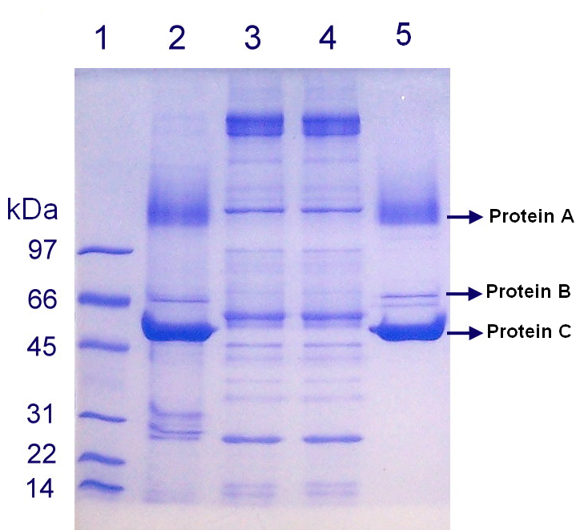

31. T F Protein A is larger in size than Protein C.

32. T F There is less of Protein C than Protein B.

33. T F Lane 3 visible on this gel contains the protein standard.

34. T F Approximate size of Protein C is no less than 45 kDa.

35. Major gene defect associated with HNPCC which was the focus of our project was:
a. nonsense mutation of mismatch repair system
b. suppression of tumor genes
c. activation of mismatch repair genes
d. missense mutation in the MSH2

36. Repetitive (microsatellite) DNA regions are usually more unstable and prone to mutations because:
a. DNA polymerase tends to slip and insert the wrong nucleotide base as it makes the new DNA strand in this region
b. RNA polymerase cannot function properly in this region of DNA
c. They are not a part of the coding sequence in a gene
d. They are not a part of a normal chromosome

37. In studying the role of MSH2 in HNPCC, we were using E. coli bacteria because:
a. E. coli lacks the MSH2 gene and therefore are a good test organisms
b. When E. coli grows and divides it also rapidly replicates the plasmid to produce multiple copies of the pMSH2 for molecular studies
c. Bacteria like E. coli are easy to work with in the laboratory
d. Understanding the role of MSH2 in E. coli will help us better understand the role of MSH2 in HNPCC
e. When E. coli grows it expresses large amounts of MSH2 protein which can be used for analysis

38. Part of the coding sequence of a gene is AAGGTCCTC. How many nucleotides does it code for in the messenger RNA for a gene? How many amino acids does it code for in the protein?
a. 9 nucleotides and 9 amino acids
b. 9 nucleotides and 3 amino acids
c. 3 nucleotides and 9 amino acids
d. 3 nucleotides and 3 amino acids

39. Polymerase chain reaction (PCR) is:
a. a way in which cells can increase the amount of mRNA
b. a means of amplifying the amount of DNA in a cell
c. a means of amplifying a specific segment of DNA in the lab
d. a nuclear reaction that leads to mutations in microsatellite DNA

40. A mutation that results in the formation of a stop codon and subsequent premature termination of protein synthesis is a:
a. Missense mutation
b. Frameshift mutation
c. Silent mutation
d. Nonsense mutation

Assay Questions (10 points each):
41. Based on your knowledge of the complementation assay please look at the example of the plate in Figure 1 and interpret the results for the Mutant MSH2 gene. Be as comprehensive as possible. ____________________________________________
________________________________________________________________________________________________________________________________________________________________________________________________________________________________________________________________________________________________________________________________________________________________________________________________________________________________________________________________________________________________________________________________________________________________________________________________________________________________________________________________________________________________________________________________________________________________________________________________________________________________________________________________________________________________________________________________________________________________________________________________________________________________________________________________________________________________________________________________________________________________________________________________

42. Using the provided Figure 2 analyze and interpret the data shown, and provide conclusions of the experiment. Be as comprehensive as possible. (10 pts)
________________________________________________________________________________________________________________________________________________________________________________________________________________________________________________________________________________________________________________________________________________________________________________________________________________________________________________________________________________________________________________________________________________________________________________________________________________________________________________________________________________________________________________________________________________________________________________________________________________________________________________________________________________________________________________________________________________________________________________________________________________________________________________________________________________________________________________________________________________________________________________________________________________________________________________________________________________________________________________________________________________________________________________________________________________________________________________________________________________________________________________________________________________________________________

43. BioWorkbench Question (10 pts)

Using provided sequences of Wild type and Mutant allele of the amyloid beta gene and tools in the Bioworkbench software please answer to the following questions:
  - What is the length of the ORF in Wild type sequence?
________________
  - What is the length of the ORF in the Mutant gene sequence? _____________
  - What is the length of the protein generated by the Wild type __________ and Mutant ORF______________
  - What is the specific location of the mutation in the nucleotide sequence? ________________________________________________________________________________________________________________________ (what is the number of the nucleotide changed, what is the specific nucleotide change i.e. A to C)

  - What is the specific location of the mutation in the protein sequence? ____________________________________________________________
(provide the number in the sequence and the name of the changed amino acid)

  - What kind of mutation is this?___________________________________ ___________________________________________________________
  - What would be the name of this mutant? __________________________________________________________

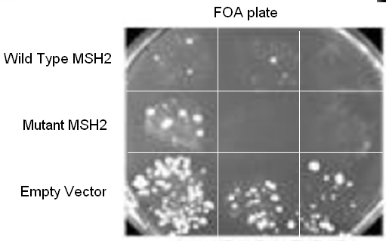

Figure 1 . Picture reveals results of the 5-FOA complementation assay. 5-FOA plate was spotted with yeast transformed with plasmids containing either Wild Type MSH2, Mutant MSH2 or with an empty plasmid and incubated for 48 hrs at 30°C.

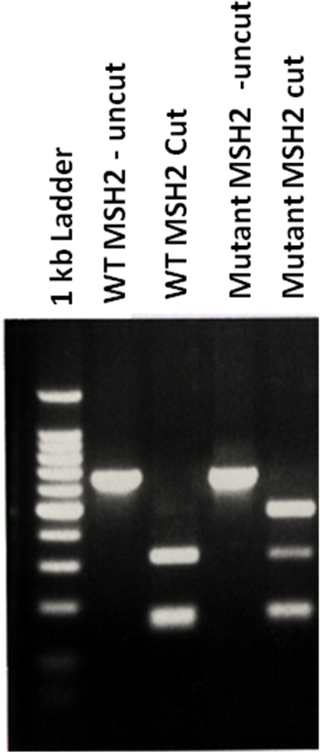

Figure 2. Image represents 2 % agarose gel electrophoresis of DNA samples following enzyme restriction analysis with BstYI enzyme.

